NSerio Corp. (Hand-off)

|  |  |
| --- | --- |
| Date | Services Performed For: |
| March 7, 2022 | **Translation Project** |

**NSerio Internal Deliverable Parameters**

|  |  |
| --- | --- |
| **Agile Style** | Scrum |
| **Estimated By** |  |
| **Kick Off Date** | March 8, 2022 |
| **Completion Date** | March 15, 2022 |
| **Client’s POC** |  |
| **Unit Testing Coverage** | 70% to new code |
| **Team** |  |
| **Name** | **Role** |
| Edward Santiago | Dev |
| Johan Santiago | Dev |
| **Product Owner** | Miller Torres |
| **Project Manager (Scrum Master)** | Miller Torres |
| **Is a user guide needed?** | Yes |
| **Browser Compatibility?** | Chrome, Firefox, Edge on Windows main |
| **Are there external Sources? Which Sources? Can we get access to them? Get this info from the client** | Docker   * <https://hub.docker.com/editions/community/docker-ce-desktop-windows/> * <https://docs.docker.com/desktop/windows/install/>   LibreTranslate   * <https://github.com/LibreTranslate/LibreTranslate#run-with-docker> * <https://libretranslate.com/docs/#/translate/post_translate> |
| **Risks** | * The team doesn’t have knowledge about docker or LibreTranslate. * We need an API key. |
|  |  |

**Business Problem**

A client requires an application to upload and translate a file.

**Requirements:**

* + **Requirements**
    - Create an app to translate a document using the LibreTranslate API.
    - The application should only translate word and txt documents.
    - Users must be authenticated to use the application.

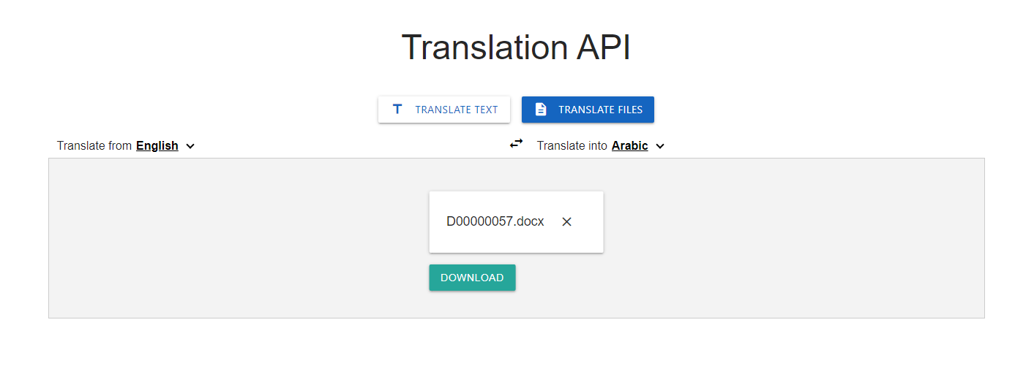

* + Nonfunctional requirements
    - Web application build using vue.